October 2019 — CCOHome Digest

Great News to Share!
We’re producing a Survival Coat for the Homeless, et. Al
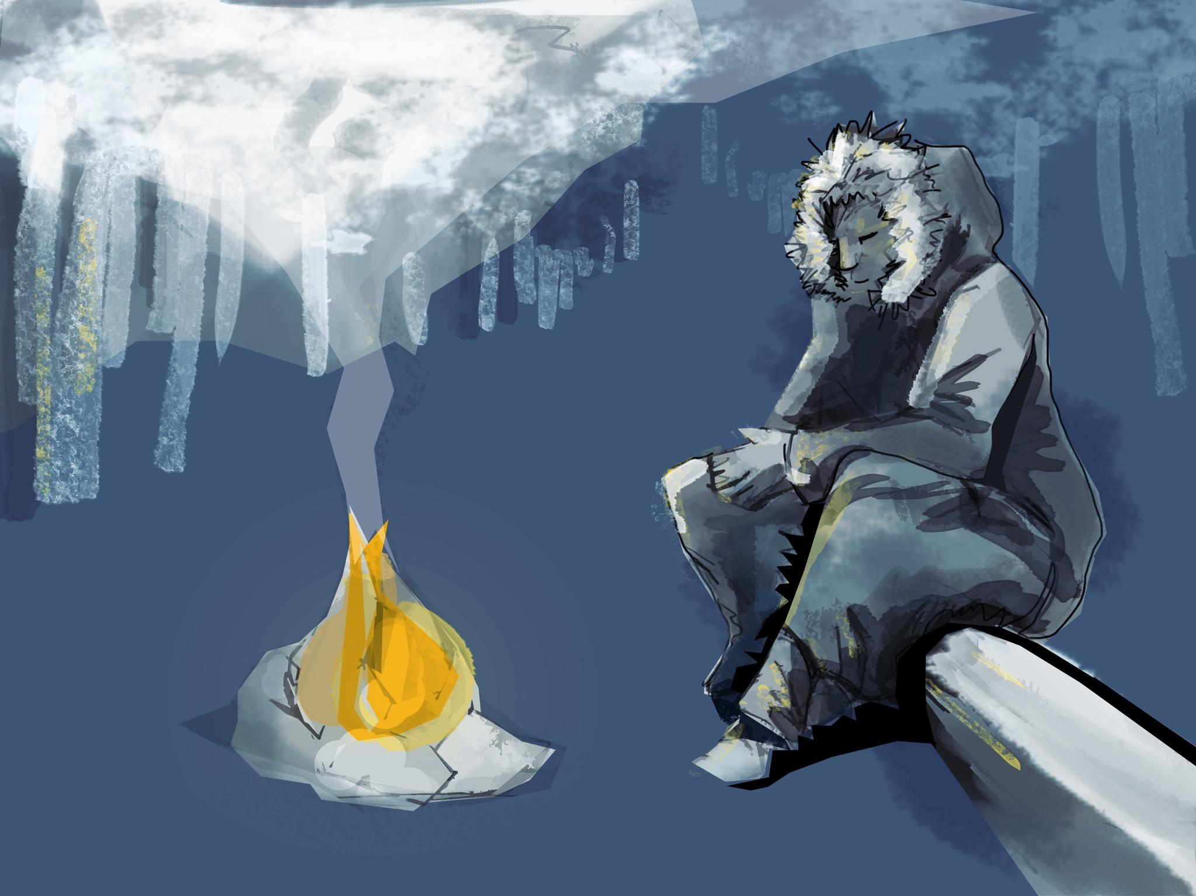
The wearable sleeping bag coat (designed early in 2017 by President & CEO Donna Mae Baukat) will be in production soon. Starting with the pattern and prototypes, our Board have unanimously voted to conduct field tests this winter. The coat will contain a few inside pockets of winter survival components and an individual tent. Compact and lightweight, it is designed for people experiencing homelessness. Donna Mae’s hope is for the survival coat to be sufficient for Sub-Zero temperatures, to be made available to shelters at cost and to be given to people experiencing homelessness. Field tests by people living in Southwest Colorado will prove the concept for long-wearing, warmth and rugged use. Instead of carrying a sleeping bag, the coat is compact with a built-in panel that accommodates both feet for comfort when sleeping--without removing the coat. An individual tent is in design and development, and it will be stored in a compartment of the coat. Ultimately, the goal is to create a product distributed by the unhoused to other unhoused around the county in a distribution center planned for La Plata County. On-the-job training of the homeless and unskilled individuals is part of the business plan. We are hoping for a successful field test by Spring 2020. Other products to serve people experiencing homelessness are in conceptual stages.
To learn more about the Community Compassion Outreach social enterprise, contact us by telephone at (970) 236-1540. Visit us at https://www.communitycompassionoutreach.com to learn more about our programs.
THIS MONTH’S
TOP STORIES
Village of Hope Development
Community Compassion Outreach has been unsuccessful in identifying a parcel. We continue to search for small and large parcels with access to sufficient water supply and sewers. You may know that the City and County contracted Athena Group to develop a homeless strategy to be adopted. We are pleased to report that CCO’s Village of Hope is being considered in the strategy for permanent affordable and low-barrier housing with wrap around services. Your continued support is greatly appreciated.

We want to hear from you!

Take this CCO quick five question survey to let us know what you think needs to be done to end homelessness in Durango and beyond.
Click here.

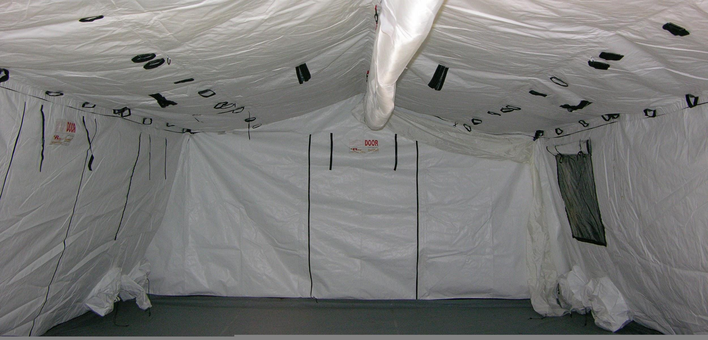

SOFT SHELTER WINTER EMERGENCY SHELTER
If an emergency brick & mortar building is unavailable to protect people in Durango from winter’s threat of Hypothermia, how about a soft tent about 18ft x 36ft for a fair number of unhoused persons.
A a soft shelter is an alternative to using a building like the Exhibit Hall at the county’s fairgrounds. The community could work together to transport the unhoused to stay out of freezing temperatures. Generators for heat and lights could temporarily shelter people who live in vehicles and makeshift tents. A homeless man last winter was sleeping in his car when frost bite affected all of his toes on both feet, which were amputated. We hope to avoid such injuries for people camping in the hills. Volunteers may be trained by CCO’s retired mental health professionals and shelter-experienced personnel in collaboration with local health providers to manage services during times of freezing temperatures.
It is our hope that something can be done to plan for this winter and to prevent serious injuries like frostbite and/or death by Hypothermia. The following is why CCO is concerned for the Homeless:

“Hypothermia can occur when you are exposed to cold air, water, wind, or rain. Your body temperature can drop to a low level at temperatures of 50°F (10°C) or higher in wet and windy weather, or if you are in 60°F (16°C) to 70°F (21°C) water. Early symptoms include:
- Shivering.
- Cold, pale, or blue-gray skin.
- Lack of interest or concern (apathy).
- Poor judgment.
- Mild unsteadiness in balance or walking.
- Slurred speech.
- Numb hands and fingers and problems performing tasks.
- Late symptoms include:
- The trunk of the body is cold to the touch.
- Muscles becoming stiff.
- Slow pulse.
- Breathing that is shallow and slower.
- Weakness or sleepiness.
- Confusion.
- Loss of consciousness.
- Shivering, which may stop if body temperature drops below 90°F (32°C).”
[Hypothermia and Cold Temperature Exposure current as of September 23, 2018; Author: Healthwise Staff; Medical Review: William H. Blahd Jr. MD, FACEP - Emergency Medicine, Adam Husney MD - Family Medicine, Kathleen Romito MD - Family Medicine; https://www.uofmhealth.org/health-library/aa53968spec#tp21233]

COFFEE & CONVERSATIONS W/HOMELESS & FOOD-INSECURE

More than 650 meals served in 36 weeks. . .Your Giving Feeds Hunger!
Since Saturday 12/1/2018, we continue to share our picnics with an average of 20 hungry persons each week. During the warm season, as many as 60 have been fed on a single Saturday with home-cooked casseroles, soups, salads, fruit & vegetables, chili, grilled hot dogs, desserts, and bottled water and more.
We need more volunteers to donate home-cooked food or hot beverages to serve people at the new encampment on La Posta Road near the Purple Cliffs. There are thirty (30) or more who are allowed to leave their tents up all day, but it’s a long walk to meals at Durango Manna Soup Kitchen. Disabled people (medical & mental illnesses) need drinking water and at least one good meal each day. Please help us to give every human soul at Purple Cliffs life-sustaining food & water. Join Us!
Only one winter stormy day kept us away from Schneider Park (12/29/2018). One of our volunteers brought his snow plow to clear the parking lot from the pile of snow left by the city’s snow plows. Hot beverages on a cold day brought our guests who don’t have shelter, or they have very low income.
Please feel free to drop-in with a platter of food any time! Get to know the people who call Durango their home, but are unhoused. CCO gives hope by collecting funds for new -20F degree sleeping bags, tents, clothing, and personal items for people living in survival mode in the woods or other uninhabitable places. You may donate on our website here: https://www.communitycompassionoutreach.com/donate.html
CCO CTA’s (Calls To Action)

As we think about winter fast approaching, it is time to truly consider what will happen to our friends who are outside in the cold. While there are many initiatives that are being worked on for longer-term solutions, many of us think, “What can we do when we see someone in need?” Many of us wish we had a magic wand to fix the situation, to heal another’s pain and suffering, to solve this seemingly intractable conflict.

We at Community Compassion Outreach have been involved up close and personal with the issue of homelessness for years. Collectively, we have talked with experts, done our research, have been close to homelessness ourselves, and we know what needs to be done. Most simply and honestly, we— as a community — can end homelessness in Durango and beyond if we work together.

Here is what we know will help:

Today:
- We want to hear from you! Take this short five-question survey to let us know what you think needs to be done to end homelessness in Durango and beyond. Click here.
- Learn more about our coats and how they will save lives. Click here.
- Join our Facebook page and share our page with others. Click here.
- Forward this email to all of your family and friends.

Tomorrow:
      - Come to our next Coffee & Conversations. Learn more by clicking here.

2020:
  - Help us to secure a location for our Village of Hope. Learn more by clicking here.

Our mission is to assist individuals and families to survive and to exit homelessness one essential house at a time!

READ MORE ON OUR WEBSITE
Tax deductible donations are welcomed!
Community Compassion Outreach, Inc., 501(c)(3) Nonprofit | EIN 82-5001338
361 S. Camino Del Rio, Unit 225, Durango, CO 81303-7997 | (970) 236-1540

